Laboratory Exercises
3.35. Consider the ER diagram for the AIRLINE database shown in Figure 3.21.
Build this design using a data modeling tool such as ERwin or Rational Rose.
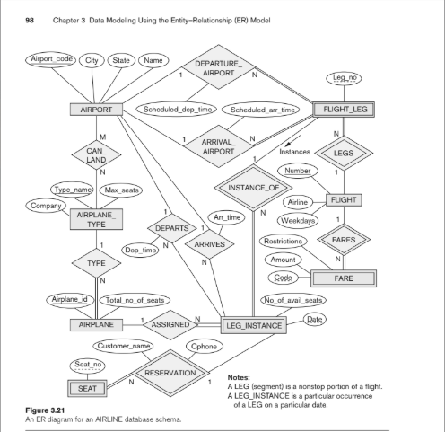
ER:
Table Airport {
airport_code varchar [primary key]
city varchar
state varchar
name varchar
}

Table Airplane_Type {
type_name varchar [primary key]
company varchar
max_seats int
}

Table Airplane {
airplane_id int [primary key]
total_no_of_seats int
type_name varchar
}

Table Flight {
flight_number varchar [primary key]
airline varchar
weekdays varchar
}

Table Flight_Leg {
flight_number varchar
leg_no int
dep_airport_code varchar
arr_airport_code varchar
scheduled_dep_time time
scheduled_arr_time time
indexes {
(flight_number, leg_no) [pk]
}
}

Table Leg_Instance {
flight_number varchar
leg_no int
date date
no_of_avail_seats int
airplane_id int
dep_time time
arr_time time
dep_airport_code varchar
arr_airport_code varchar
indexes {
(flight_number, leg_no, date) [pk]
}
}

Table Fare {
code varchar [primary key]
amount decimal
restrictions varchar
flight_number varchar
}

Table Seat {
seat_no varchar [primary key]
airplane_id int
}

Table Reservation {
flight_number varchar
leg_no int
date date
seat_no varchar
customer_name varchar
cphone varchar
indexes {
(flight_number, leg_no, date, seat_no) [pk]
}
}

// -- Khóa ngoại --
Ref: Airplane.type_name > Airplane_Type.type_name
Ref: Flight_Leg.flight_number > Flight.flight_number
Ref: Flight_Leg.dep_airport_code > Airport.airport_code
Ref: Flight_Leg.arr_airport_code > Airport.airport_code

Ref: Leg_Instance.(flight_number, leg_no) > Flight_Leg.(flight_number, leg_no)
Ref: Leg_Instance.airplane_id > Airplane.airplane_id
Ref: Leg_Instance.dep_airport_code > Airport.airport_code
Ref: Leg_Instance.arr_airport_code > Airport.airport_code

Ref: Fare.flight_number > Flight.flight_number
Ref: Seat.airplane_id > Airplane.airplane_id

Ref: Reservation.(flight_number, leg_no, date) > Leg_Instance.(flight_number, leg_no, date)
Ref: Reservation.seat_no > Seat.seat_no

